**Mobile App Design Document (UFCF7H-15-3)**



**MoodTracker**

**Student Name: Ilwad Abdi (22014624), Ayan Ibrahim (19027655), Zainab Ahmed (22039114)**

**Github link:** [**https://github.com/ilwad123/mood**](https://github.com/ilwad123/mood)

**Video link:** [**https://drive.google.com/file/d/1SkujWeVto7NtMwpZ2t7hKjZL5s11qgUw/view?usp=sharing**](https://drive.google.com/file/d/1SkujWeVto7NtMwpZ2t7hKjZL5s11qgUw/view?usp=sharing) **[download the video to view]**

Table of Contents

Requirements 2

Context / High Concept: 2

Target Users: 3

User Stories: 3

Initial Research: 4

Functional / Non-functional Requirements: 4

UI Requirements: 6

Wireframes 7

Technical Diagrams: 7

User Flow / Navigation: 7

App lifecycle: 8

Composites 9

Mock-ups: 9

App Icon: 10

Color Schemes: 10

References: 10

# **Requirements**

## Context / High Concept:

Mental health apps are becoming a staple in the tracking applications landscape. With their vast features, they ‘offer unique opportunities for self-management of mental health and well-being in a cost-effective way’ (Neary and Schueller, 2018). However, Mental health apps provide an alternative to clinical appointments, however, they may not fully replace the care given, but they can at least alleviate some of the problems the user has experienced. Regulating emotional and mental health has made it easier due to tracking users’ well-being. In addition, the app enables historical data to be used as a basis for clinical appointments, especially when the user is experiencing anxiety.

Mood Tracker is a feature-rich mental health app designed to empower users in managing their emotional well-being by tracking mood, anxiety, and stress levels, along with a built-in medication tracker. The app provides a structured way for users to monitor their mental health patterns over time, offering insightful visual representations such as a mood count bar chart, a stress pie chart, and an anxiety level line graph. These tools help users identify behavioural trends and correlations between their mood and other factors, promoting greater self-awareness and mindfulness.

Users can easily log their mood by selecting from a range of expressive emoji icons corresponding to their emotional state at a specific day and time. To offer a more holistic overview, the app allows the selection of stress and anxiety levels separately. Users can indicate their stress and anxiety intensities by interacting with intuitive buttons and have the option to add personal notes for context, enabling a deeper reflection on triggers and coping strategies.

The app's historical data feature enables users to review their previously recorded entries for mood, stress, and anxiety, displayed as expandable cards containing date and time stamps. If stress or anxiety and the associating feeling notes is recorded alongside mood on the same day, the cards expand to reveal these additional details for a more comprehensive view of the user's mental health journey. They also have a built-in search function which checks through the entries and displays the matching entries. A calendar filter where the user can select a specific date, and the matching entries are displayed.

Additionally, MoodTracker includes a dedicated advice and support page featuring essential resources, key contacts, and external links to mental health organisations and helplines. This ensures that users can access professional support when needed, further enhancing the app’s role as a self-care and wellness companion.

## Target Users:

The target audience for this project is university students aged 18 and above. University students often face significant stress, anxiety, and mood fluctuations due to the demands of their academic life. This app aims to offer a structured approach to managing emotional well-being by providing tools for tracking mood, stress, and anxiety levels. By enabling users to monitor these elements, the app promotes self-awareness, emotional clarity, and healthier coping strategies during challenging times.

The app’s goals are:

* Tracking Stress and Anxiety: Users can log their stress and anxiety levels using a simple button-based interface, allowing them to reflect on patterns over time.
* Tracking Mood: Users can select their mood using emoji icons representing various emotional states, linked to specific dates and times.
* Creating Visual Graphs: The app generates graphs, such as bar charts, line graph and pie charts, offering a clear overview of mood trends and emotional patterns.
* Tracking Medication: Users can plan, schedule, and monitor their medication intake to support both physical and mental health management.
* Support Page: A dedicated section providing key advice, mental health resources, and contact links specifically for UWE students to facilitate immediate access to support.

## User Stories:

These user stories below outline the functionalities of the app and the way the user would interact with it:

* As a new user, I want to register and create a new account so I can access the MoodTrackr app based on my credentials (UserID). When registered on the app, it should direct to the reminder page with options to either select mood or go to the overview page.
* As a returning user, I want to login with my credentials (Username and password) so I can access the app and be directed to the overview page.
* As a user, I want to select my current mood for the current moment using emojis so I can see the entries saved on the history page and updated in the overview page in graphs and charts.
* As a user, I want to access my medication tracker through the bottom navigation bar so I can edit and save my medication.
* As a user, I want to select my anxiety and stress levels from different pages so that they can be tracked in the History page as entries and visualized in the Overview page with charts, including an anxiety line graph and a stress pie chart.
* As a returning user, I want to log into the app and the app to save the login credentials, so I don’t have to login each time I exit the app, only if I log out of the app.
* As a user, I want to use recorded mood entries from mood page so they can be shown as a mood count bar chart in overview page.
* As a user, I want to use recorded mood, anxiety and stress entries so they can be shown as cards with datetimes on the history page.

## Initial Research:

Mobile health applications have become increasingly popular in recent years, with several now being used in professional settings to track young people's mood and mental health. These applications have unique advantages in terms of accessibility and cost-effectiveness, making them potentially transformational tools for mental health care (Widnall et al., 2020).

One example is Moodpath, a mental health application that helps users obtain a better knowledge of their mental health. The key features include guided mood tracking, observations of mental health patterns, and tailored coping mechanism strategies. The application also offers instructional content, such as information about mental health disorders, and is a resource for increasing emotional self-awareness. Additionally, Moodpath helps users prepare for professional mental health consultations by creating extensive reports that can be shared with therapists and counsellors (Anyatonwu, 2020).

In a comparable vein, Daylio focuses on mood tracking and journaling. It enables users to document daily activities and emotional states using a combination of icons and text, allowing for the detection of patterns over time. This attribute adheres closely to user-centered design principles by stressing straightforwardness and simplicity of use, allowing users to interact with the mobile application with little friction (Wasil et al., 2022).

Nonetheless, studying these applications reveals certain user-centered design principles: transparency, customisation, and instructional help. These concepts may be immediately applied to developing this project's mood-tracking and journaling capabilities, ensuring that the application stays entertaining, encouraging, and readily available to a wide range of users.

## Functional / Non-functional Requirements:

Internal storage is used for all pages based on the userID assigned, and this is used as a data storage.

Used the agile methodology:

* Designed App design in Figma first to get an overview of the app.
* Then each member worked on their own respective section that was split into.
* Tested by using different use cases. Fixed any mistakes due to testing.

Asset collections:

* Material icons from google:
  + Used for mood icons as images to be changed colour.
  + Icons for the navigation bar.
* Images from the internet for the UWE logo

External libraries used:

* Accompanist System UI Controller used for customising navigation and status bar.
* Kotlin coroutines JetBrains needed for asynchronous programming
* Jetpack Compose for UI development
* ThreeTenABP is a library that provides the modern java.time API for date and time

|  |  |  |
| --- | --- | --- |
| **Features** | **Functional Requirements** | **Non-Functional Requirements** |
| **Advice** | Provide clickable links to articles or resources. | Advice page should load 2 seconds |
| **Mood** | * Provide a user-friendly interface for users to log their daily moods. * Displays mood prompts and emojis for quick selection * Stores the selected mood in the database | * Supports offline mode for mood logging. * Handle multiple users’ operations without crashing. |
| **Stress-Level** | * Enable users to log stress levels and feeling notes | * Ensure a simple interface for quick stress logging. |
| **Anxiety-Level** | * Provides a scale for users to log their current anxiety levels. * Displays historical trends for anxiety tracking. | * Ensures inputs are user-friendly by colour scheme. |
| **Sign-up/Login** | * Allow users to log in using email and password. * Validate user credentials like username and password validation. | * Login operations should take no longer than 3 second. * Ensures smooth registration/ login within 10 second. |
| **Storage** | * Internal storage should be able to be created and save mood, anxiety, stress, medication and login data. | * The app should not crash when saved, created, and retrieved. |
| **Mood page** | * User should be able to select their current mood as an emoji. | * Handle multiple users’ operations without crashing. |
| **Overview** | * Displays a detailed summary of user activities. * Should retrieve mood, anxiety and stress data. * Provides insights based on logged stress level as a pie chart. * Provides insights based on logged anxiety level as a line graph over time. * Provides insights based on logged mood as an overall mood count bar chart. | * Charts should load quickly and not crash the app. |
| **Main Activity** | * Acts as the central hub to navigate all app features. | * Smooth navigation between features without lagging. |
| **History page** | * Mood, anxiety and stress entries should be displayed as cards with date times. * The cards should expand if there is stress and anxiety and feeling notes in the entries. * Should generate searched words from the entries * Selected date should be generated as filtered cards in history | * UI interactions like searching or filtering should respond in real-time without noticeable delay. |
| **Reminder Activity** | * Integrates reminder with the device’s notification system. * Allows users to set, update and swich off reminder. | * Notification should trigger on time with no delays. |
| **Medication** | * Medication main page should display new medications added by user. * Edit medications page should allow users to make updates to details of medications. * Edit medications page should allow users to also delete medications they are done with. * Reminder on medications card should set reminders for users at specific time chosen. | * New medications added should show up on main page with no delays. * Users should get a reminder notification on time. |

## UI Requirements:

Through the process of research of the current mobile applications, a couple of critical UI characteristics have been found that can be identified allowing the app to make an impact out while maintaining a user-friendly experience.

* Mood Tracking Interface: A visually appealing and straightforward technique to record feelings, such as a coloured-coded mood wheel or an emoji-based pick.
* Journaling Section: A text box with additional suggestions to stimulate creative writing as well as a more introspective experience and keeping distractions to a minimum. In addition, adding an auto-save functionality for the entries so nothing is lost and they can go back to it.
* Personalised Resource Library: Use dynamic flashcards to access coping tactics, such as mindfulness exercises, and articles by tags and categories.
* Accessibility Features: To improve usability, Dark mode, adjustable font sizes, and voice input could be option for improvement.
* Integration to other existing apps: Calendar app should be synced for mood tracking and medication reminders, with it appearing on it. Also, the notification system should be able to take the reminders and notify the users of when to log their entries and take their medications.

# **Wireframes**

## Technical Diagrams:

This is the technical diagram designed to guide that development of the app. It is a wireframe that shows the layout and flow of the application. It consists of UI features that improve visualisation. This was created on Figma. Could not export fully as it was unclear so had to crop parts of it.

**User- Flow/Navigation:**

This app has been designed to be user-friendly. This navigation guide will help new users understand the purpose of each page and how to navigate around the app.

The first page contains buttons asking the user to log in or sign up. The login button allows users to log in to their existing account with the correct details, while the signup button allows them to create a new account.

After login/signup, the user should have access to the homepage, which is also the overview page. On this page, the user can navigate through the various pages on the app using the navigation bar. The navigation bar includes the overview page, the history page, the medication page and the advice page. This page also consists of a hamburger that provides options to access stress level, anxiety, and reminder pages. Each of these pages serves different purposes. The overview page also contains charts that display the count of users’ entries on the stress, anxiety and mood page.

The stress page allows users to pick their feelings for the day. It includes a note section where you can describe your feelings. Similar to that is the anxiety page, which allows you to log in your anxiety levels for the day. It also provides a section for users to write down their feelings about what bothers them.

The mood page allows users to log-in and record their mood for the day based on their emotions. The entries for mood, stress, and anxiety are displayed on the history page. On this page, the user can see their daily entry.

The reminder page allows users to set a reminder to log in daily. This is especially useful for users with busy schedules. The medications page allows the user to add details of their medications while also providing an option to remind the user to take medicines on time. The user should also be able to make changes to any existing entry. Lastly, the advice page contains information on getting help quickly. It contains contacts a user can utilise.

## App lifecycle:

1. **Log in process**: At this stage the user launches the login activity which then validates user credentials and saves the session. The app navigates to Overview activity after this.
2. **Main Navigation:** User can choose to view or manage medications, view mood/stress/anxiety data (option Activity), set reminders (Reminder activity) and view data visualizations of any of the entries made on the stress, anxiety and mood pages.
3. **Workflows:**

The app updates and saves any changes made on any pages. This is unique to userID

1. **Return to Overview or Navigate Another feature**: Return to OverviewActivity or navigate to another activity for additional tasks.
2. **Log Out:** Clears the session and navigates back to LoginActivity. This does not mean users lose data created on the app. Everything logged will still be accessed when the user logs in with the right credentials again.

# **Composites**

## Mock-ups:

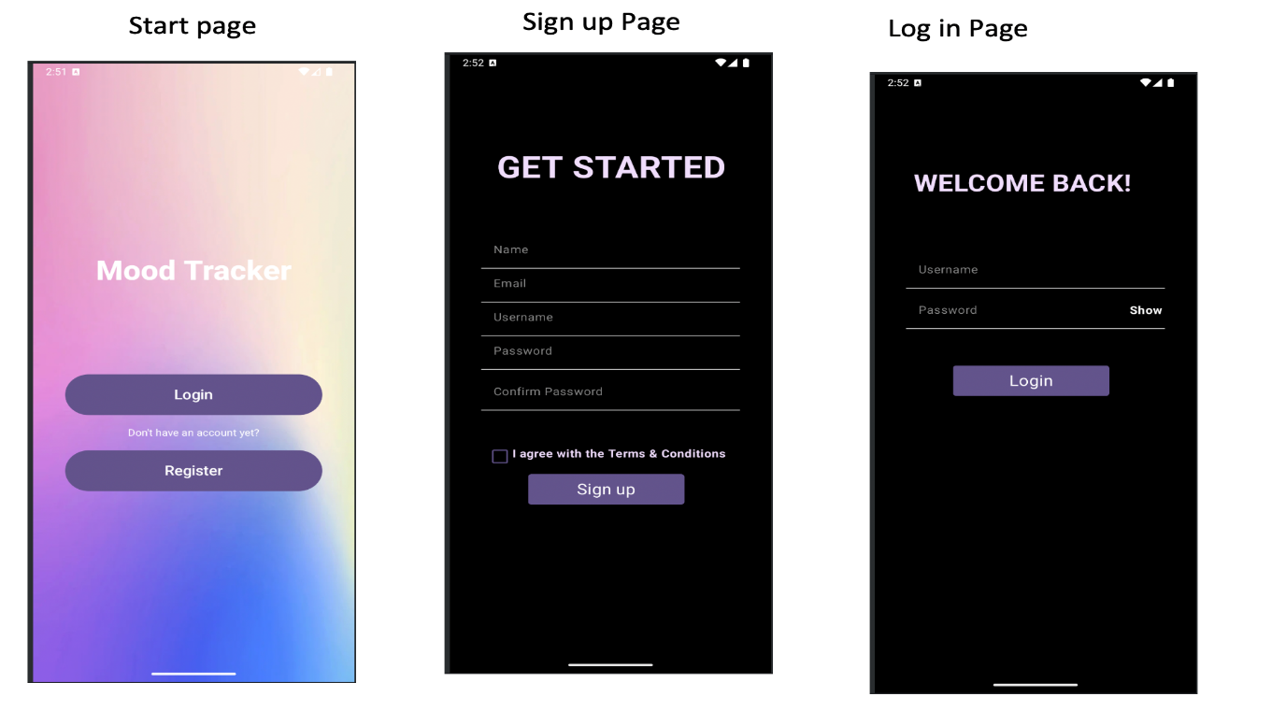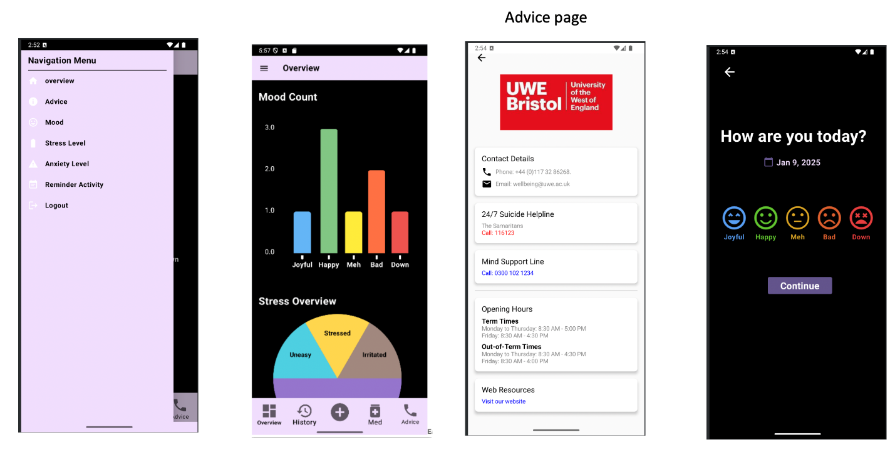

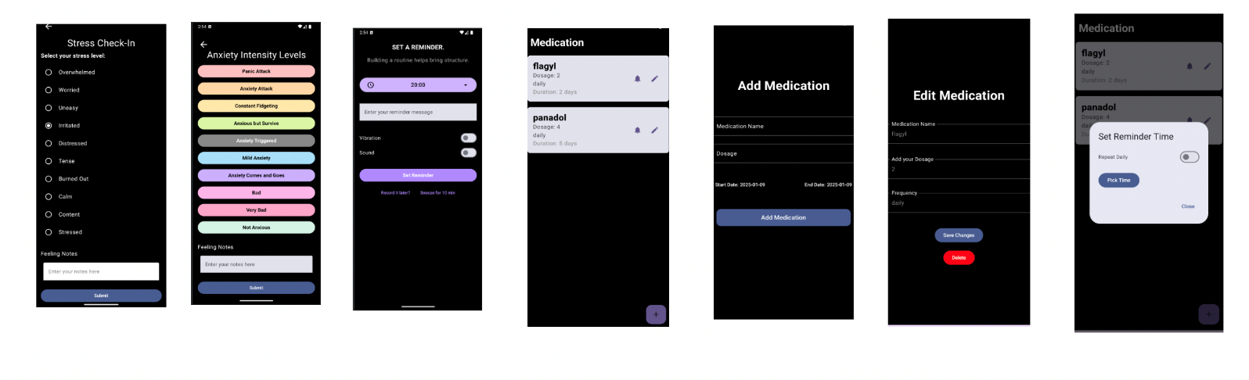**App Icon:**

This is a picture of the app icon designed. It includes colors for the palette of the project for cohesion.

## Color Schemes:

The color palette for the project includes Light purple (#f0dcfc), dark purple (#64548C), Gray, Black and white. Some of the pages include more colors for better visualisations.

## 

## References:

1. Anyatonwu, E.U., 2020. Does the Smartphone Application Moodpath Reduce Depression in African American Adults? (Doctoral dissertation, Brandman University).
2. Neary, M. and Schueller, S.M. (2018) State of the Field of Mental Health Apps. Cognitive and Behavioral Practice [online]. 25 (4), pp. 531–537. [Accessed 1 January 2025].
3. Wasil, A.R., Palermo, E.H., Lorenzo-Luaces, L. and DeRubeis, R.J., 2022. Is there an app for that? A review of popular apps for depression, anxiety, and well-being. Cognitive and Behavioral Practice, 29(4), pp.883-901.
4. Widnall, E., Grant, C.E., Wang, T., Cross, L., Velupillai, S., Roberts, A., Stewart, R., Simonoff, E. and Downs, J., 2020. User perspectives of mood-monitoring apps available to young people: qualitative content analysis. JMIR mHealth and uHealth, 8(10), p.e18140.